Colossal Grilled Harissa Shrimp
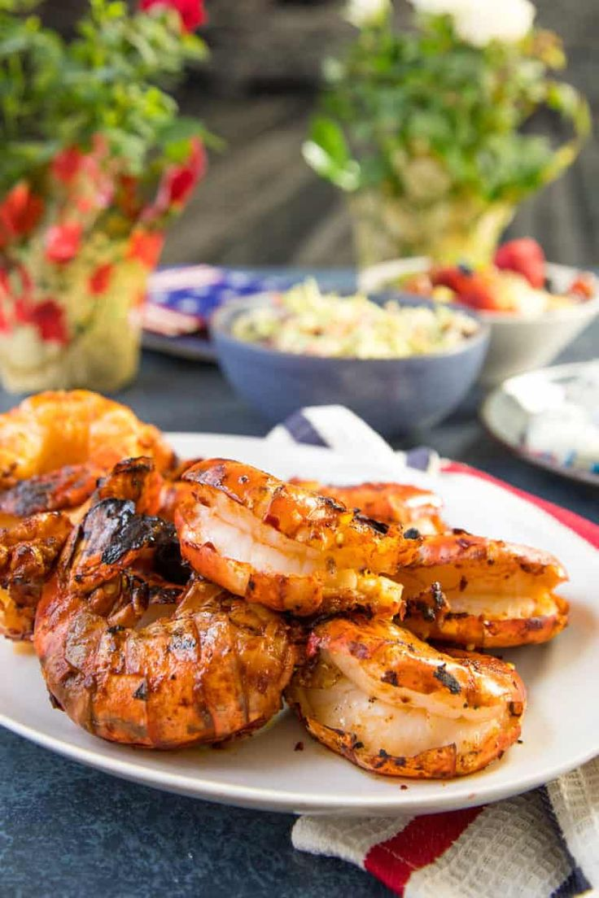
Serves 4-6

Ingredients
- 18 Colossal Shrimp about 3-4 pounds
- 1/2 cup harissa
- Juice from 2 lemon
- Salt and pepper to taste

Instructions
- Pat the shrimp dry and set them into a plastic bag or a large bowl.
- Whisk together the harissa, lemon juice and salt and pepper. Pour it into the bag or bowl with the shrimp.
- Rub the shrimp down with the harissa marinade.
- Cover and set the shrimp into the refrigerator for at least 2 hours.
- Fire up the grill to medium heat and lightly oil the grates. Grill the shrimp for about 4-5 minutes per side, until they are cooked through. They should measure 145 degrees F internally.
- Serve

